Sure-Park Management System

Software Architecture Design Document
Document ID : [5Team_Design_003]

5 (Oh!) Team
Copyright © 2016 5 (Oh!) Team All Rights Reserved.

Though every care has been taken to ensure the accuracy of this document, 5 (Oh!) Team cannot accept responsibility for any errors or omissions or for any loss occurred to any person, whether legal or natural, from acting, or refraining from action, as a result of the information contained herein. Information in this document is subject to change at any time without obligation to notify any person of such changes.

5 (Oh!) Team may have patents or patent pending applications, trademarks copyrights or other intellectual property rights covering subject matter in this document. The furnishing of this document does not give the recipient or reader any license to these patents, trademarks copyrights or other intellectual property rights.

No part of this document may be communicated, distributed, reproduced or transmitted in any form or by any means, electronic or mechanical or otherwise, for any purpose, without the prior written permission of 5 (Oh!) Team.

The document is subject to revision without further notice.

All brand names and product names mentioned in this document are trademarks or registered trademarks of their respective owners.

Document Information
5 (Oh!) Team,
LG Electronics,
Executive Training Program,
ISR(Institute for Software Research)
Carnegie Mellon.

Contact us: sanghee3.lee@lge.com

About This Document

Revision History
Version | Date | Comment | Author | Approval
0.1 | 2016-06-16 | Document outline, draft version | Sanghee Lee | Jaedo Jin
0.2 | 2016-06-20 | Design alternatives | Sanghee Lee | Jaedo Jin

Purpose
This document describes architecture of SurePark Management System and the important decisions we have made.

Scope
This document includes overall and sub system architecture.

Audience
This document’s audience is as follows.
- All Stakeholders
- Project Manager
- Architect
- Development Team

Related Documents
Following documents can be reference for understand this document.
Document ID | Comment
5Team_Analysis_001 | Architectural Driver Specification (including contexts)
5Team_Design_001 | Interface description document (JSON)
5Team_Design_002 | Design document (Enterprise architecture)
5Team_Design_004 | Database design document (MySQL)
5Team_Test_001 | Test strategy
5Team_Test_002 | Test cases
5Team_Test_003 | Test results
Glossary
Glossary in this document are described..
Glossary | Description
JSON | JavaScript Object Notation
JDBC | Java Database Connectivity
SQL | Structured Query Language

Contents

1 Project introduction 7
1.1 Project overview 7
1.2 Context 7

1.2.1 Market context 7
1.2.2 Organizational context 7
1.2.3 Business context 8
1.2.4 Technological context 8

2 Architectural drivers 9
2.1 High level functional requirements 9
2.2 Constraints 10
2.2.1 Business constraints 10
2.2.2 Technological constraints 10
2.3 Quality attributes 11
2.3.1 Most significant quality attributes 11

3 System context 12

4 System architecture design 14
4.1 In short summary 14
4.2 Dynamic perspective 15
4.2.1 Design alternatives 15
4.2.2 Design decision 18
4.2.3 Dynamic Behavior 19
4.2.4 Additional design rationale 27
4.3 Physical Perspective 29
4.3.1 Design decision 29
4.3.2 Design alternatives : Arduino with server 30
4.4 Static Perspective 31
4.4.1 Elements description 32
4.4.2 ParkHere for Android application 32
4.4.3 Traceability between functional requirements and elements 33
4.5 Tactics 34
4.5.1 Tactics For Availability 34
4.5.2 Tactics For Security 35
4.5.3 Related Quality Attributes 35

5 Subsystem Architecture Design 36

Project introduction

Project overview
The project sponsors is Geoff’s Transportation and Parking Services (GPTS LLC).
GPTS LLC own several parking garages and lots, have concerns about inefficiencies in their parking garages and lots. We have to enable drivers to easily find a parking facility with available parking slots and reserve them.

Context

Market context
Stakeholders | Owner, Driver(s), Attendant(s), Development Team
Functional  Expectations | Reduction driver frustration and enable them to easily find a parking  facility with available parking slots and reserve them.
System Access | Users want to access the system via laptops, pads, phones.

Table 1. Market Context

Organizational context
Roles and  Responsibilities | Project Manager  Architect  Requirement Manager  Test Manager  Development Team  : Server developer (Business logic)  : UI Application developer  : Embedded system developer (Arduino)
Team culture | 1. Open-minded  2. Be the first  3. Make customer happy

Table 2. Organizational Context

Business context
Date of delivery | 6/24, 2016
Time resources | 1,050 hours (35 Working days * 6 Hours * 5 People)
Strategy | More efficiently utilize the space in their parking facilities thereby increasing profits
Cost obligations | More efficiently utilize personnel and reduce the number of people required to operate any given garage reducing operating costs
Profit model | Selling management & reservation system for parking equipment

Table 3. Business Context

Technological context
Languages | Java (Android), C/C++ (Arduino), SQL
Tools | Arduino IDE, Eclipse, MySQL
Operating systems | Windows, Arduino, Android
Hardware | Laptop, Arduino MEGA 2560 (Wi-Fi enabled), Android phones

Table 4. Technological Context

Architectural drivers
Detailed architecture driver document is described in [5Team_Analysis_001]. We describe it roughly in this document. Please refer to [5Team_Analysis_001] for detailed description.

High level functional requirements
We extract high level functional requirements from system level usecases.
UC-ID | User Goal | Description
UC 1 | Manage | Manage the whole parking lot management system  - UC 1.1 Analyze statistics on usage of parking lot  - UC 1.2 Manage current status of parking lot  - UC 1.3 Adjust parking fee  - UC 1.4 Adjust grace period for parking reservation  - UC 1.5 Manage user authority  - UC 1.6 Add/Remove parking lot
UC 2 | Reserve a slot | Reserve a parking slot by driver  - UC 2.1 Reserve a parking slot  - UC 2.2 Confirm reservation
UC 3 | Park a car | Manage the process when driver arrive/depart parking lot  - UC 3.1 Parking  - UC 3.2 Departure

Table 5. System Level Functional Requirement

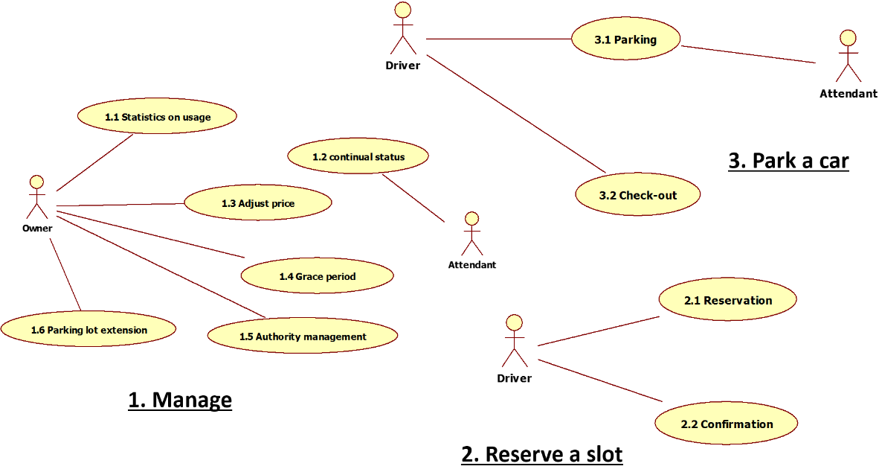

Figure 1. Use Case Diagram of Overall System

Constraints

Business constraints
Following table describes constraints of business perspective.
ID | Description
CST-01 | The system should more efficiently utilize personnel and reduce the number of  people required to operate any given garage reducing operating costs.
CST-02 | The system should reduce traffic congestion and the chance for accidents inside the parking facilities reducing liabilities.
CST-03 | The system should be scalable to N facilities.
CST-04 | The system should reduce driver frustration and enable them to easily find a parking  facility with available parking slots and reserve them.
CST-05 | The system should more efficiently utilize the space in their parking facilities thereby  increasing profits.

Table 6. Business Constraints

Technological constraints
Following table describes constraints of technological perspective.
ID | Description
CST-08 | The system cannot change the type of controller, sensors, or actuators (e g. gate lift servo), although use multiple controllers to accommodate a larger facility.
CST-10 | The system must check with the owner (course instructor) before you use open software.
CST-12 | The system should use JAVA as programming language.
CST-13 | The system should use Arduino MEGA 2560 (Wi-Fi enabled).

Table 7. Technological Constraints

Quality attributes
We have defined 18 quality attributes, and these are described in document [5Team_Analysis_001].

Most significant quality attributes
In this document we describe top 5 high priority quality attributes which can have a decisive impact on system quality and architecture.

QA ID | Quality Attributes | Priority | Difficulty
QA-18 | (Usability) User shall be comfortable using parking lot. | H | H
QA-08 | (Scalability) If owner add a parking lot, it should be reflected without stopping System. | H | M
QA-14 | (Availability) System shall be available for 24 * 7 * 365 without stop. | H | H
QA-17 | (Performance) System shall make a response for every request in 3 seconds. | H | H
QA-15 | (Security) System shall store private data with encryption | M | M

Table 8. Top priority quality attributes

System context
This System context diagram describes interaction between key stakeholders and Sure-Park Management System. There are 3 key stakeholders (Owner, Attendant and Driver), 1 external system (Payment system) and Sure-Park Management System.

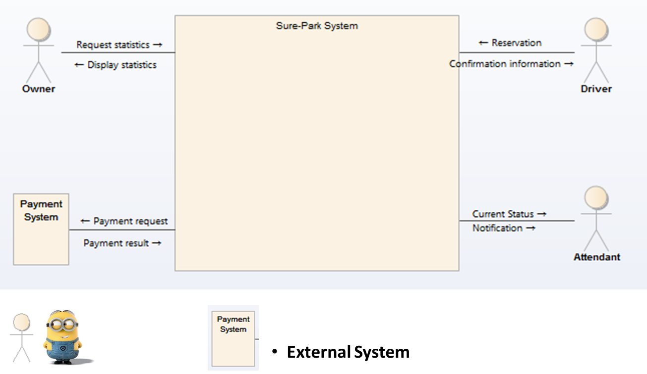

Figure 2. System Context Diagram

The main activity with key stakeholders are defined as following:
- Drivers use to reserve a parking slot.
- Owner use to manage parking lot system, monitor the system status and analyze usage data.
- Attendant use to manage assigned parking lot.

The main activity with Payment system is defined as following:
- Payment system verify driver’s payment information, accept payment request.

The scope of Sure-Park Management System development is defined as below.

- Control devices and monitor sensors in parking lot
- Provide user interface as owner, attendants and drivers
- Interact with driver at entry gate
- Manage parking lots and analyze the statistics information

System architecture design
This chapter describes overall system architecture and important architecture design decision.

In short summary
Based on architecture drivers and system context, we can summarize our environment as follows.

System context : There are shared resources and services that large numbers of distributed clients wish to access, and for which we wish to control access or quality of service.

What should we do : By managing a set of shared resources and services, we can promote modifiability and reuse, by factoring out common services and having to modify these in a single location, or a small number of locations. We want to improve scalability and availability by centralizing the control of these resources and services.

After analyzing customer requirements, we found there were several requirements and constraints for design decisions.

ID | Details | Consequences
CST-13 | The system should use Arduino MEGA 2560 (Wi-Fi enabled). | - We have to design “Parking Lot Controller” as an independent element.
FR-201 | System shall provide at least one method for parking lot reservation. | - We have to design “Reservation Client” as an independent element.  - We have to design network-based system to reserve a parking slot in distance.
FR-304 | System should be able to receive the confirmation information from driver. | - We have to design “Parking Lot Kiosk” as an independent element.

Table 9. Main requirements/constraints

In this point of view, we should make at least 3 independent elements with independent hardware. These decision affect a lot on our design for Sure-Park Management System.

Dynamic perspective
This section shows dynamic view of overall system. We designed several alternatives and we choose one based on primary quality attributes.

Design alternatives

#1 Client-Server
We adopt “Client-Server Pattern” to provide shared resources/services and to support multiple clients.
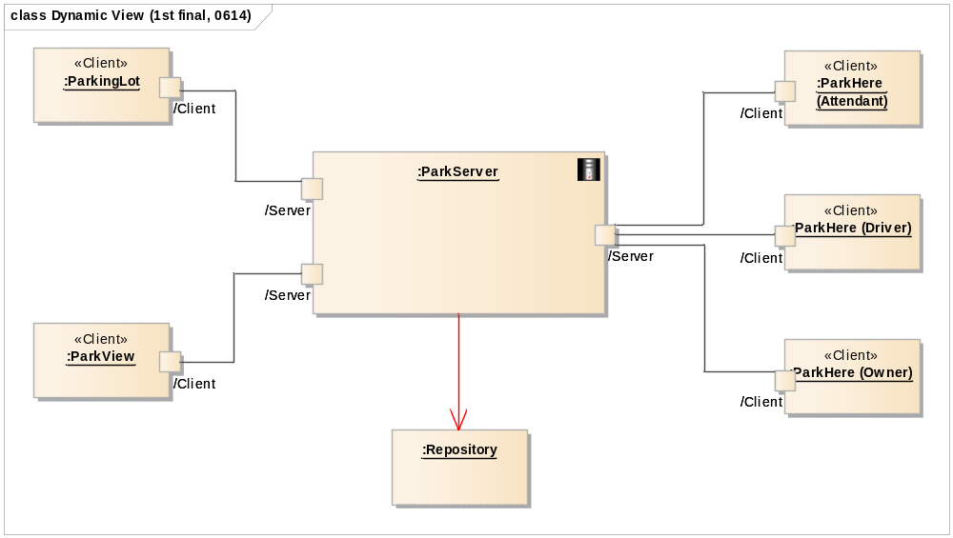
Figure 3. Dynamic perspective of overall system

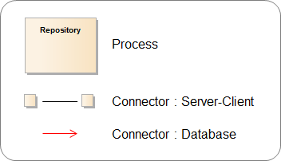

Figure 4. Legend for dynamic perspective

Sure-Park management system consists of 5 independent sub-system. Figure 3 shows dynamic structure of each sub-system and the relationships among them. Each sub-system operates with independent process.

Every sub-system is connected with “ParkServer Process” as the center which has server role. ParkServer Process manages data from each Client Process and delivers necessary control information to ParkingLot Client.

There are 2 types of connector. The first one is a connector between server and client using TCP/IP. The IP of server is static, 192.168.1.192, and this information is deployed in each clients. We want to design with DNS, but we cannot apply within restricted situation. And we use JSON type of message. The detailed reason for using JSON is described in 4.2.4.2.
The second one is a connector between server and database. We only provide one access point to database, to keep it secure, and we use JDBC driver to connect our MySQL database.

#2 Client-Server (integrated server)
We made another design with integrated process, parking lot and server, to reduce interfaces and delay between devices. It is almost same with design alternatives #1. (Legend is same as figure 4)

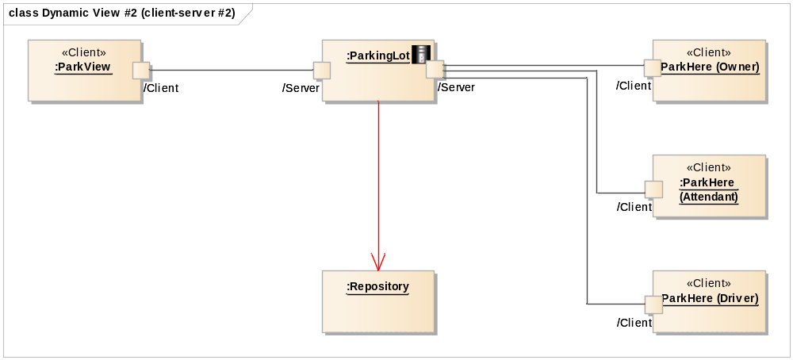
Figure 5. Dynamic perspective of overall system

#3 Shared repository with middleware
We need a repository for storing and analysis of parking lot usage data, and the clients need to use authentication data (e.g. credit card, password and so on). So we designed another one with centralized repository with middleware.

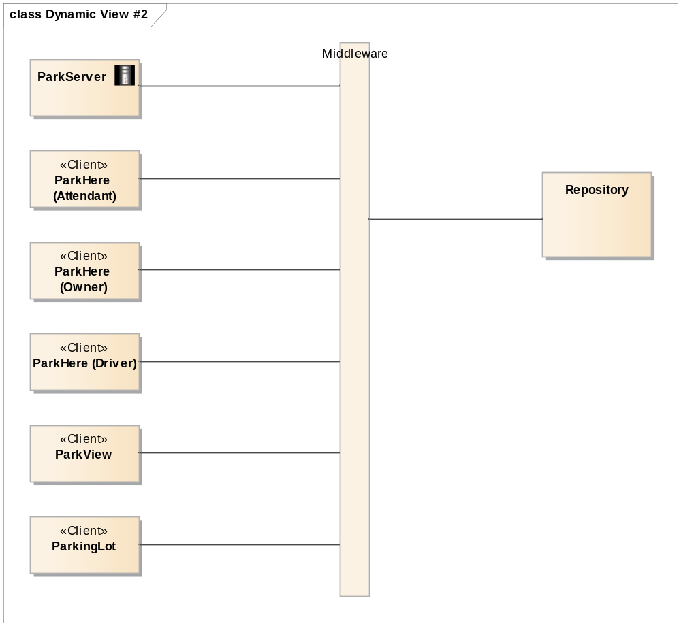
Figure 6 Dynamic design alternatives : Shared data with middleware

There is just one type of connector. We have a connector between client and middleware. It supports to connect to repository. In this architecture every client communicates only with repository. Every command, situation is stored in repository.

Design decision
We compare two design alternatives with architecture drivers, mainly quality attributes.

Alternatives | Promotes | Inhibits | Remarks
Client-Server  (#1) | - scalability and availability by centralizing the control of these resources and services  - modifiability and reuse, by factoring out common services and having to modify  these in a single location, or a small number of locations  - All data is stored on the server, which generally offers a greater control of security than client machines | - Server can be a performance bottleneck.  - Server can be a single point of failure.  - Decisions about where to locate functionality (in the client or  in the server) are often complex and costly to change after a  system has been built | - This architecture can support simultaneous control of devices.
Client-Server  (#2) | - scalability and availability by centralizing the control of these resources and services  - modifiability and reuse, by factoring out common services and having to modify  these in a single location, or a small number of locations  - All data is stored on the server, which generally offers a greater control of security than client machines | - Server is proved to be a performance bottleneck. Arduino cannot support performance.
Shared repository w/ Middleware  (#3) | - Use of this pattern has the effect of decoupling the producer  of the data from the consumers of the data; hence, this pattern supports modifiability  - Improving portability and interoperability by defining standard interfaces  - Improving scalability by separating the application and database management layers, which may be separately upgraded to cater for an increase in load | - The shared-data store may be a performance bottleneck.  - The shared-data store may be a single point of failure.  - Producers and consumers of data may be tightly coupled. | - To support simultaneous control of devices, we need to additional patterns (e.g. publish-subscribe pattern).

Table 10. Design decision on dynamic perspective

Both of design (#1, #3) support scalability and modifiability (maintainability). Performance issue is also arose both of design. In our quality attributes QA-17. QA-16, our system should be controlled simultaneously. In this aspect, client-Server pattern #1 has advantage, and this is why we decide to use client-server architecture.

Dynamic Behavior
This section describes system’s dynamic behavior for satisfying high level functional requirement, based on design alternatives #1.

(UC 1.1) Parking lot statistics
The operations of each element when owner request to display the statistics for parking lot.
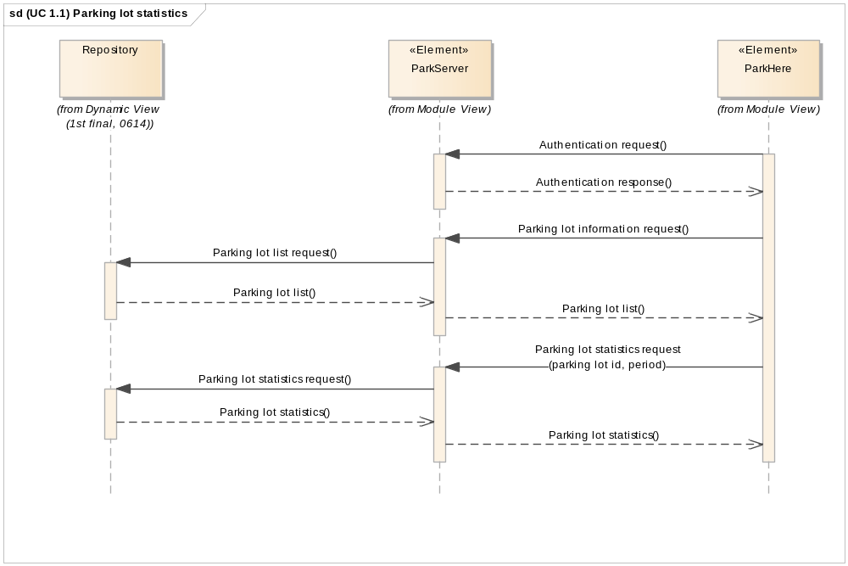
Figure 7. (UC 1.1) Parking lot statistics sequence diagram

(UC 1.2) Parking lot status
The operations of each element when attendant request to display current status of parking lot.
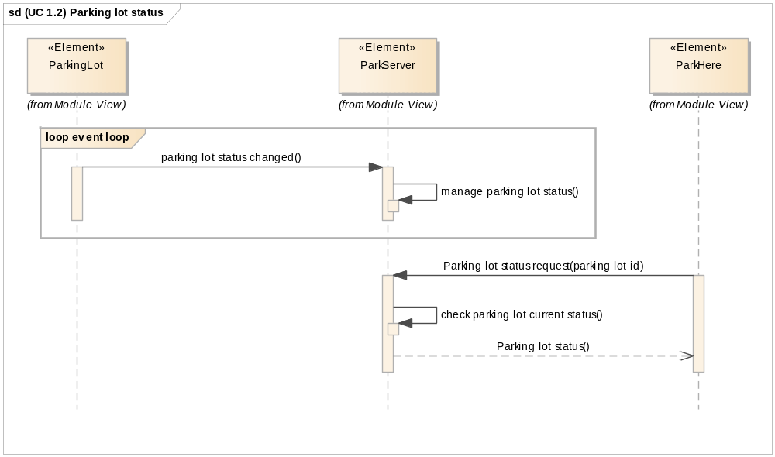
Figure 8. (UC 1.2) Parking lot status sequence diagram

(UC 1.3) Adjust parking fee
The operations of each element when owner request to adjust parking fee for selected parking lot.
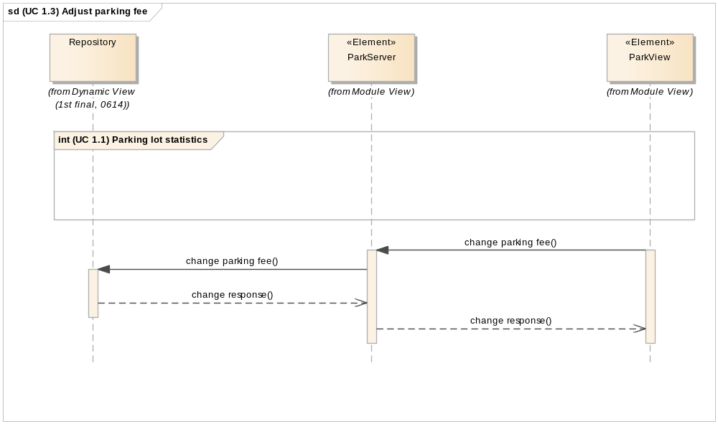
Figure 9. (UC 1.3) Adjust parking fee sequence diagram

(UC 1.4) Adjust grace period
The operations of each element when owner request to adjust grace period for selected parking lot.
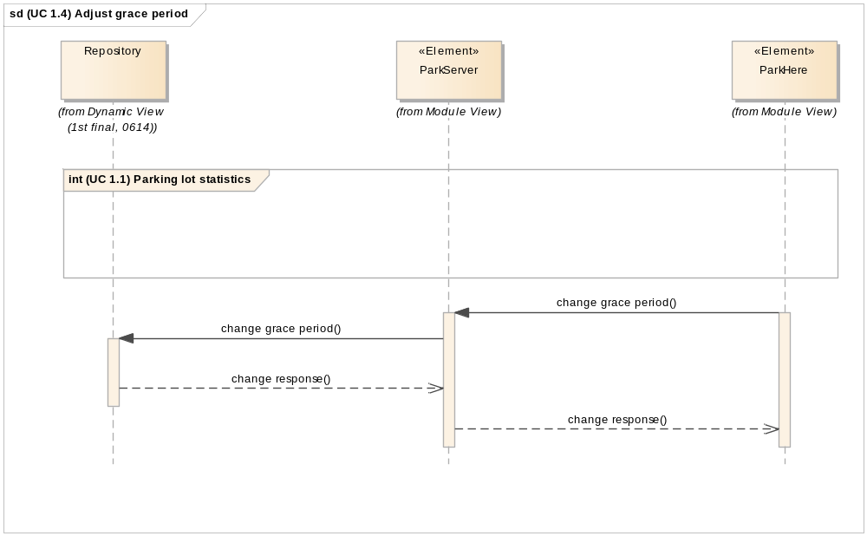
Figure 10. (UC 1.4) Adjust grace period sequence diagram

(UC 1.5) Authority management
The operations of each element when owner request to adjust grace period for selected parking lot.
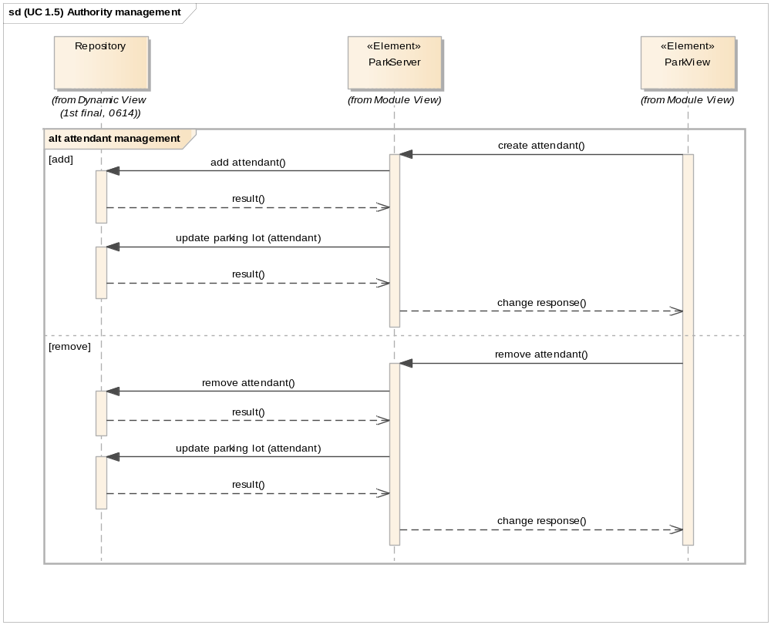
Figure 11. (UC 1.5) Authority management sequence diagram

(UC 1.6) Parking lot extension
The operations of each element when owner request to add/remove parking lots.
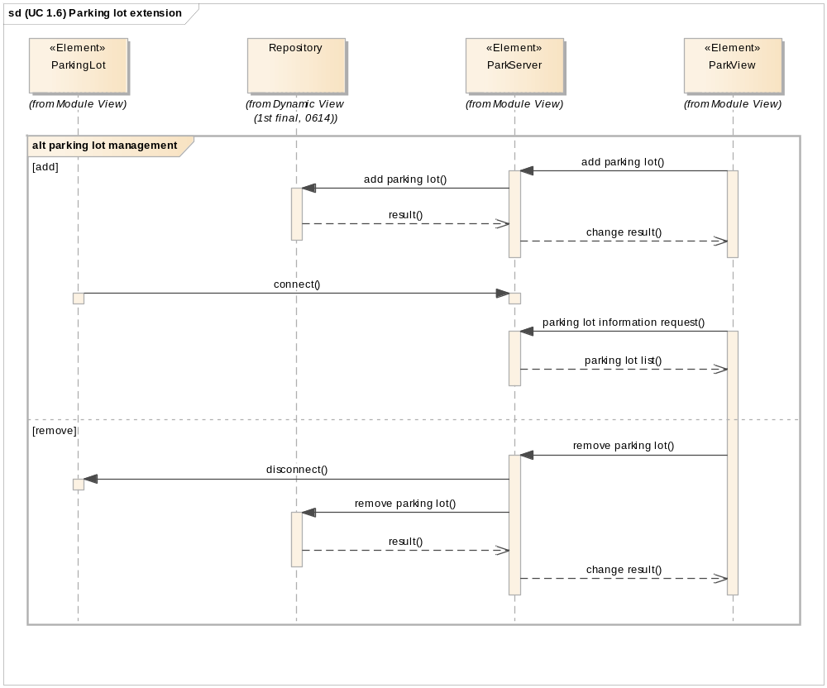
Figure 12. (UC 1.6) Parking lot extension sequence diagram

(UC 2) Reserve a slot
The operations of each element when driver make a reservation and confirm a reservation.
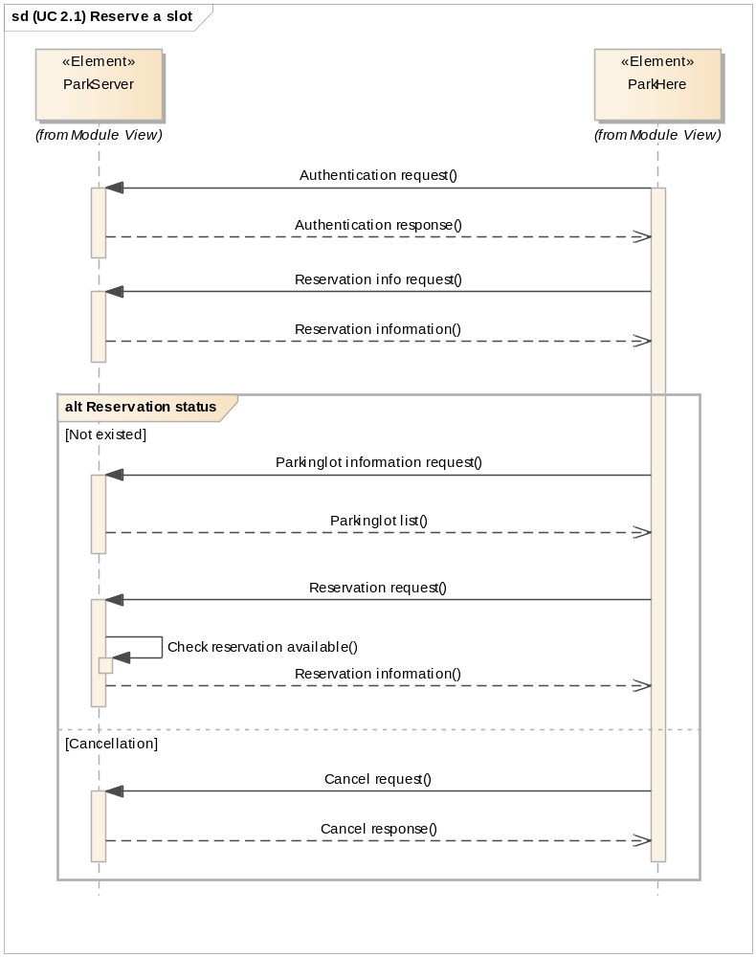
Figure 13. (UC 2) Reserve a slot sequence diagram

(UC 3.1) Parking
The operations of each element when driver arrives parking lot.
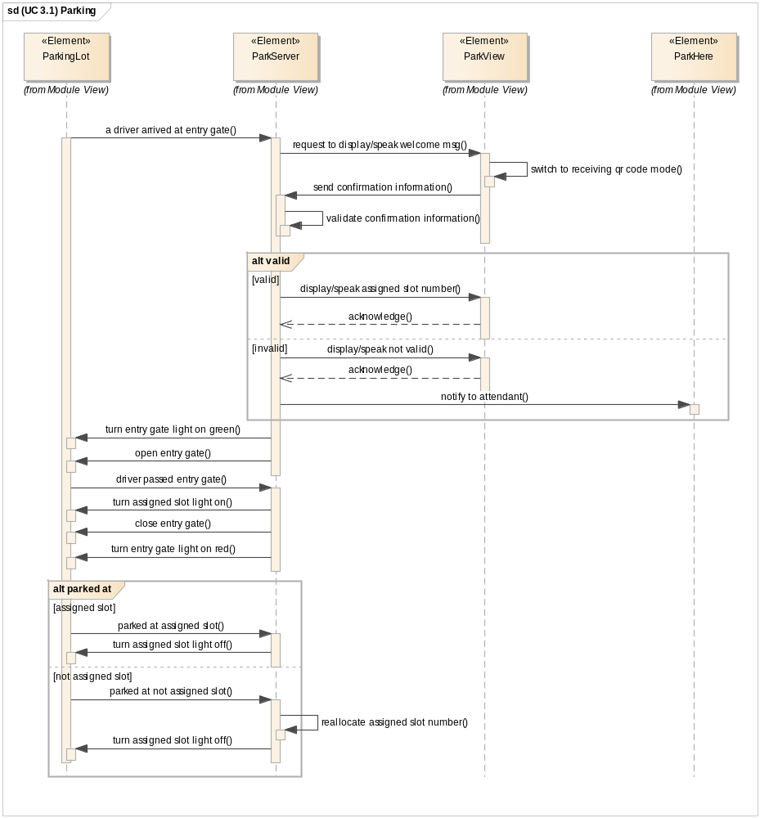
Figure 14. (UC 3.1) Parking sequence diagram

(UC 3.2) Check-out
The operations of each element when driver depart parking lot.
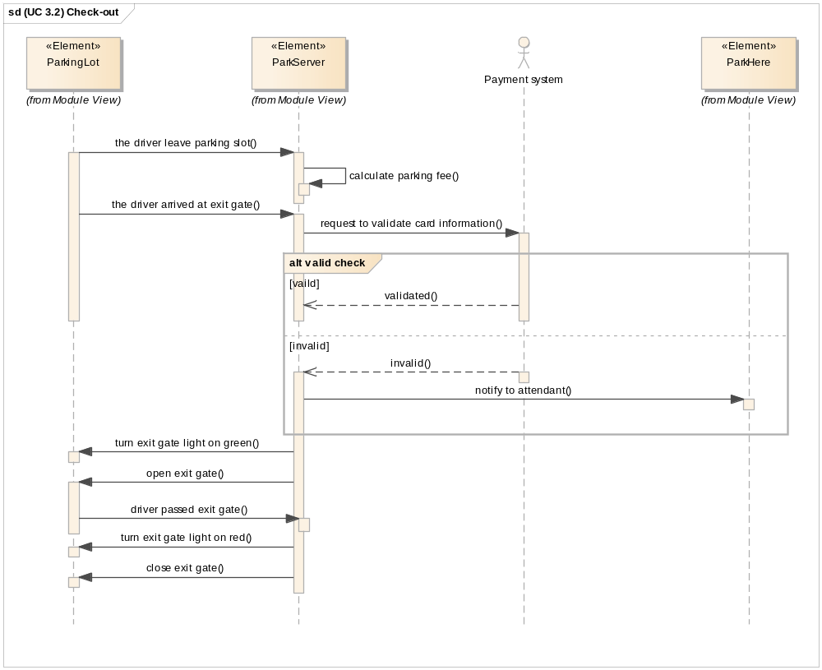
Figure 15. (UC 3.2) Check-out sequence diagram

Additional design rationale

Reason for using database
ParkServer receives various kinds of data continuously, server have to provide reliable statistics information to owner, which will be used to manage the business. And server also should store user information with reliability and security.
In this situation, we decided to use database because we need to keep managing various kinds of data and to get consistency for data even though we can manage the data using data structure.

There are various kinds of database in this world. We decided to use MySQL in this project. After analyzing system requirement, we have found that MySQL can provide scalability, availability, and portability. We have not chosen NoSQL database because we do not have experience to use NoSQL before, and we do not have much time to debug when we meet critical problem with it.

Design Decision | Manage data using MySQL
Reason | Need to keep maintaining various kinds of data during operation
Promoted  Quality Attributes | Availability, Reliability, Security, Performance
Trade-Off | Database can be a performance bottleneck

Table 11. Rationale of using Database

Analysis for selecting protocol
There is a JSON based protocol between elements (except database). We analyzed several candidate protocols, and the result is as in the below table.

Protocol | Strength | Weakness
JSON | Compatibility for different languages  Support various libraries  Good performance | Need JSON parsing library
XML | Standardized format  Widely used standard | Parser is complex and heavy  Poor performance when format is complex
RAW Object Socket  (java) | Can use in Java easily | Restriction to use in different languages
String Base Socket | Easy to parse based on string  Can be used in low performance devices | Easy to restore data after cracking network packet (security weakness)
Binary Base Socket | Large data can be transferred with small bandwidth | High possibility to miss parsing bit-unit command

Table 12. Result of protocol analysis

JSON based socket is selected according to above analysis, because of compatibility for different languages, good performance, and security. JSON based protocol, which has great extensibility for mobile devices, has been selected for user interface.

Design Decision | JSON based protocol is selected for user interface
Reason | Extensibility to various kinds of clients like mobile device
Promoted  Quality Attributes | Modifiability, Security
Trade-Off | Message can be longer than string base socket, it can make performance issue.

Table 13. Rationale of using JSON

The computing power of Arduino is very low, and it is hard to process long JSON messages. So, we executed a test to find out the limit of its performance. The result shows me that Arduino afford at least 200 bytes as a message. With this result, we designed interfaces between ParkingLot and ParkServer, described in [5Team_Design_001].

Physical Perspective
This section shows physical view of overall system. We designed several alternatives and we choose one based on primary quality attributes.

Design decision
Figure 8. shows physical connection among physical elements. Every element is connected to server through WIFI and dedicated port.
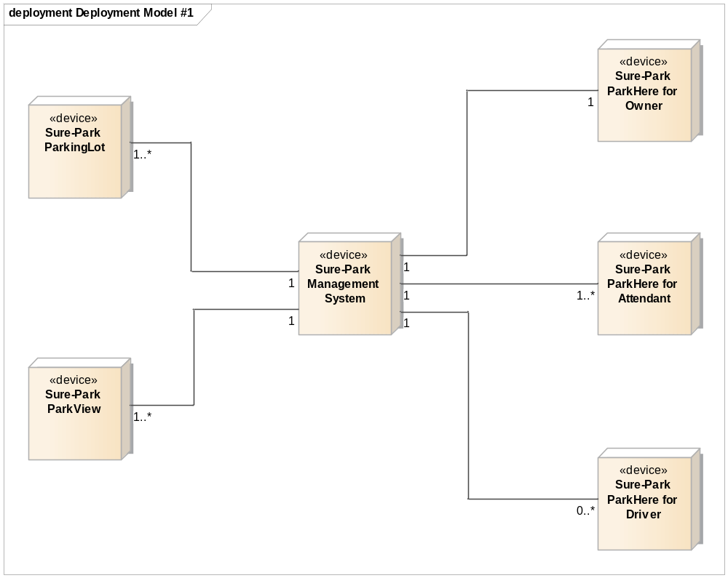
Figure 16 Physical Perspective of Overall System Architecture

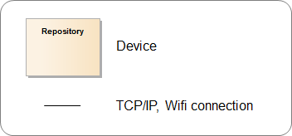

Figure 17. Legend for physical perspective

Physical Perspective shows about the hardware information, network information. Most design rationales of this design comes from early design decisions, in Table 9.

Design alternatives : Arduino with server
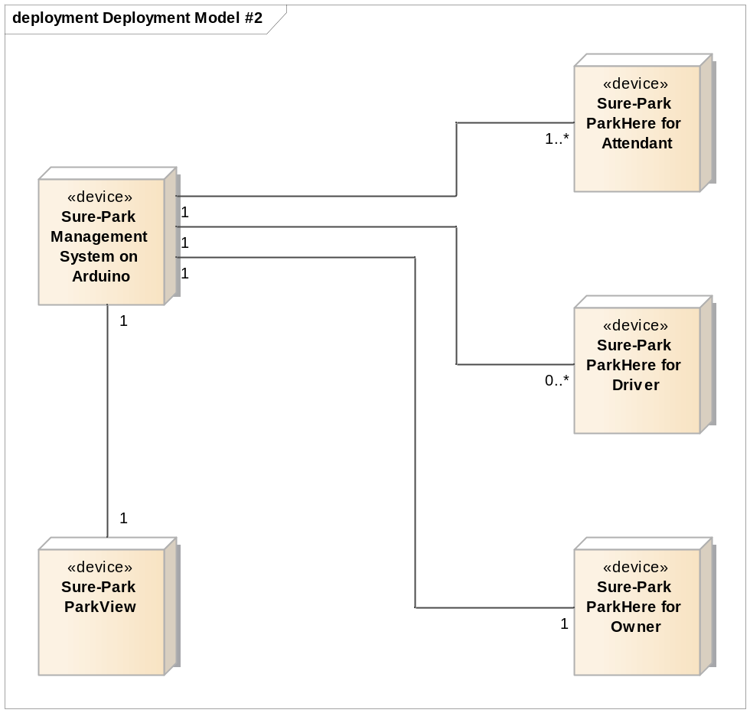
Figure 18 Physical design alternatives : Arduino with server

There are a lot of solutions to implement server using Arduino. So, we made an alternative physical design to reduce network complexity, achieve easiness on development and test. But there is a constraints on Arduino. It cannot make multiple threads or processes, and its performance is too low to work as server and parking lot. The detailed result is same with 4.2.1.2.

Static Perspective
Sure-Park Management System consists of 4 sub-systems and the static view of use relationship is as in the following figure.

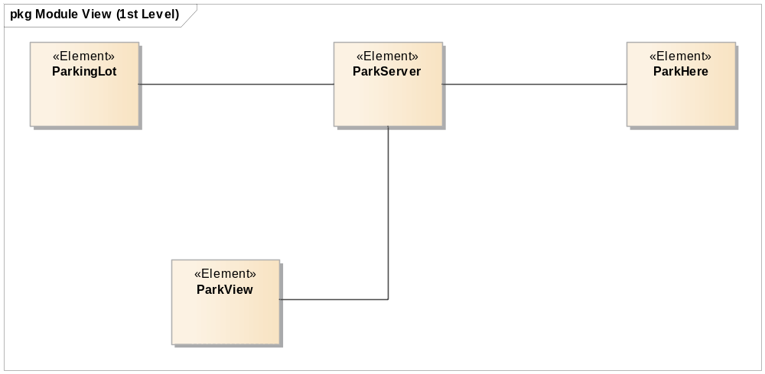
Figure 19 Static Perspective of Overall System Architecture

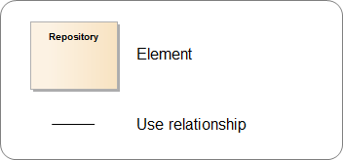
Figure 20. Legend for physical perspective

This is typical ‘Client-Server’ architecture pattern which server is in center of architecture. We assigned developer using subsystems of static perspective.

Elements description
In 1st level of system module view, we have 4 elements – ParkServer, ParkingLot, ParkHere and ParkView. Detailed information of each element is as follows.

Elements | Responsibility | Constraints | # of reqs. | Assignee
ParkServer  (SE-01) | * manage reservation, parking, statistic data  * manage authority : owner, driver, attendant | * must communicate with lots of other elements (parking lot, applications)  * must stay connected with parking lot | 62  (97%) | Yongchul Park,  Jaedo Jin
ParkingLot  (SE-02) | * control devices in parking lot by management system's request  * monitor sensors in parking lot and send to management system | * can add/remove devices/sensors in parking lot  * just follow command of management system | 16  (25%) | Daedon Jeon
ParkHere Owner  (SE-03) | * display statistics for parking lot  * manage authorities for registered attendants  * manage parking lot price, grace period  * add/remove parking lots | * controlled by various authorities  * display statistics for owner in 3 seconds  * Android application. | 17  (27%) | Kimoon Lee
ParkHere  Attendant  (SE-04) | * display current status of parking lot  * receive notification for emergency |  | 3  (5%) | Kimoon Lee
ParkHere  Driver  (SE-05) | * reserve a parking slot with reservation information  * display reservation information with confirmation information  * can cancel the reservation |  | 12  (19%) | Kimoon Lee
ParkView  (SE-06) | * interact with driver at entry gate  * display/speak welcome message  * receive confirmation information from driver via QR code  * display/speak assigned parking slot information | * need to reduce energy consumption  * controlled by management system | 3  (5%) | Yongchul Park

Table 14. Element description/work assignment

ParkHere for Android application
At the beginning of this project, we have two alternatives to develop user interface for users, web-based or Android app-based.

First, we considered to develop with web-based system. It needs to develop web server, web applications and several web pages. But we did not have enough experience for development using web. So, we should choose another option, Android App.

In our team, we have two android developers. And if we decide to develop with Android app, we just develop server, not web server. So, we decide to develop Android based application for user interface.

Traceability between functional requirements and elements
We made a traceability matrix between requirements and elements. It shows that we assign whole requirements to module elements.

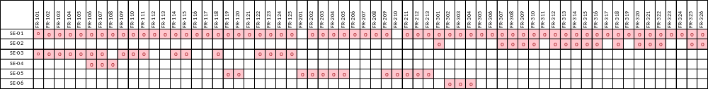

Figure 21. Traceability matrix

Database design
We store important data in database. Category for storing data is user information (user, authority table), parking lot information (parkinglot table), reservation information (reservation, parking table) and statistics data (change_history, occupancy_rate table). The ERD between these tables is as follows.

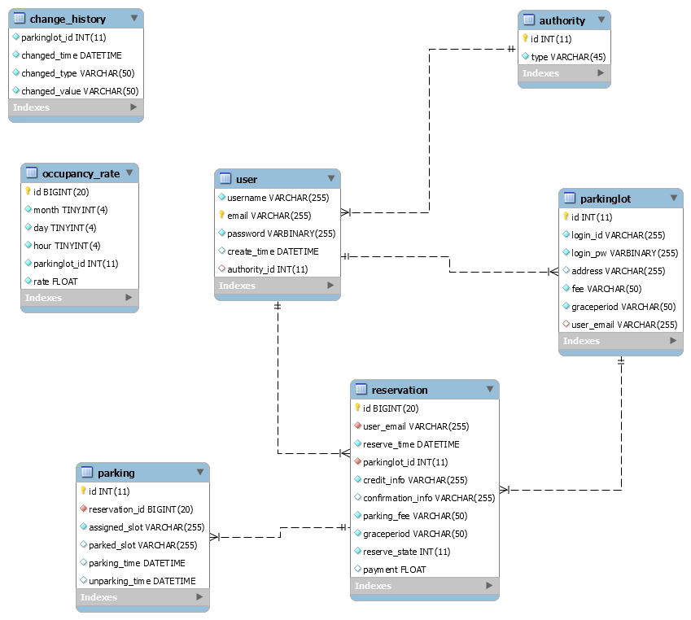

Figure 22. Entity-Relationship Diagram

User information
There are 2 tables for user information. User table manages data for users (owner, attendant, driver) and authority table manages authority type (owner type, attendant type, driver type). The detailed information for each table is as follows.

Table | Field | Type | Remarks
user | username | VARCHAR(255) | - field for user’s name
user | email | VARCHAR(255) | - field for e-mail, which would be used as id for user  - primary key
user | password | VARBINARY(255) | - field for password of user  - will be stored encrypted
user | create_time | DATATIME | - field for user create time
user | authority_id | INT | - field for authority  - foreign key from authority table

Table 15. User table

Table | Field | Type | Remarks
authority | id | INT | - field for authority id
authority | type | VARCHAR(45) | - field for authority type  - 1 : owner type, 2 : attendant type, 3 : driver  - authority type can be expanded by market change, so we designed with flexibility

Table 16. Authority table

Parking lot information
There are a table for parking lot information. It stores detailed information of parking lot.

Table | Field | Type | Remarks
parkinglot | id | INT | - field for sequential integer id  - primary key
parkinglot | login_id | VARCHAR(255) | - field for distinguishing parking lot
parkinglot | password | VARBINARY(255) | - field for password of parking lot  - will be stored encrypted
parkinglot | address | VARCHAR(255) | - field for parking lot address
parkinglot | fee | VARCHAR(50) | - field for parking fee / 30 minutes
parkinglot | graceperiod | VARCHAR(50) | - field for grace period of reservation
parkinglot | user_email | VARCHAR(255) | - field for attendant id

Table 17. Parking lot table

Reservation information
There are 2 tables for reservation information. Reservation table manages reservation request and service information, and parking table manages parked information of reservation. Parking data is created when driver with reservation arrives parking lot.

Table | Field | Type | Remarks
reservation | id | BIGINT(20) | - field for sequential integer id  - primary key
reservation | user_email | VARCHAR(255) | - field for distinguishing who made reservation
reservation | reserve_time | DATETIME | - field for reservation start time  - YYYY:MM:DD:HH:MM
reservation | parkinglot_id | INT | - field for parking lot id to reserve
reservation | credit_info | VARCHAR(255) | - field for credit card information  - will be stored encrypted
reservation | confirmation_info | VARCHAR(255) | - field for reservation confirmation information  - this data will be transformed to QR code
reservation | parking_fee | VARCHAR(50) | - field for parking fee, when driver make a reservation
reservation | graceperiod | VARCHAR(50) | - field for grace period, when driver make a reservation
reservation | reserve_state | INT | - field for reservation status  - reserved, canceled, parked, completed
reservation | payment | FLOAT | - field for result of pay-check

Table 18. Reservation table

Table | Field | Type | Remarks
parking | id | INT | - field for sequential integer id  - primary key
parking | reservation_id | BIGINT(20) | - field for reservation id
parking | assigned_slot | VARCHAR(255) | - field for assigned slot
parking | parked_slot | VARCHAR(255) | - field for parked slot
parking | parking_time | DATETIME | - field for parking start time
parking | unparking_time | DATETIME | - field for unparking time

Table 19. Parking table

Statistics data
There are 2 tables for statistics data. Occupancy_rate table stores occupancy rate for every hour. Change_history table stores change history of parking fee and grace period.

Table | Field | Type | Remarks
occupancy_  rate | id | BIGINT(20) | - field for sequential integer id  - primary key
occupancy_  rate | month | TINYINT(4) | - field for month
occupancy_  rate | day | TINYINT(4) | - field for day
occupancy_  rate | hour | TINYINT(4) | - field for hour
occupancy_  rate | parkinglot_id | INT | - field for parking lot id
occupancy_  rate | rate | FLOAT | - field for occupancy rate of specified hour

Table 20. Occupancy_rate table

Table | Field | Type | Remarks
change history | parkinglot_id | INT | - field for parking lot id  - primary key
change history | changed_time | DATETIME | - field for change time
change history | changed_type | VARCHAR(50) | - field for type, parking fee and grace period
change history | changed_value | VARCHAR(50) | - field for value

Table 21. Change_history table

Tactics

Tactics for performance (QA-17)
To satisfy customer, system should response or process the request in 3 seconds. Other devices afford to achieve this quality attribute, but Arduino’s low performance should be managed. In this chapter we will introduce tactics to achieve performance goal using Arduino.

Manage sampling rate
Data of stall sensor is not stable. So, we should sample the value of stall sensor. We found that it took 20 milliseconds to get the sensor value once. We need to find the adequate sampling rate.
…

Schedule resource
There are 3 type of work in Arduino. The first one is communicate using network, the second one is controlling devices, and last one is monitoring sensors. Detailed activity is as follows.
…

Tactics for availability (QA-14)
All the operation cannot work if connection to server is failed when we use Client-Server pattern. It is the most important to keep maintaining connection with server for securing system availability. We used heartbeat method to check if connection to server is stable.

Heartbeat
Every client related parking lot system should inform their status to server. We use heartbeat mechanism to monitor these connections.

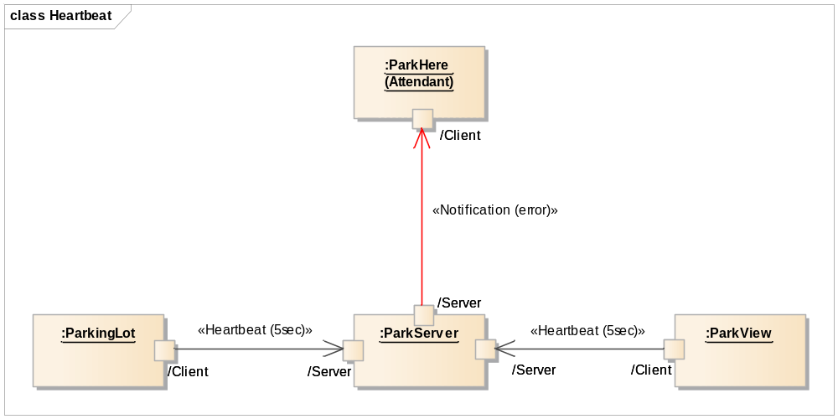
Figure 23. Heartbeat between server and clients (period : 5 sec)

ParkingLot and ParkView send heartbeat to ParkServer every 5 seconds. They are very closely related to drivers, who are customers of system. If element goes wrong, ParkServer notify this information to Attendant.

Timestamp
We use timestamp between ParkingLot and ParkServer, because they handle very important messages. Detailed messages are described in [5Team_Design_001].

Tactics for security (QA-15)
There are some private data, for example, credit card, password, and confirmation information. To keep these data secure, we apply some tactics.

Authenticate actors
System uses id/password to identify and authenticate actors. When any clients want to connect server, they should send message for authentication. The server checks authentication information then grants connection to client. These sequence is described as follow.

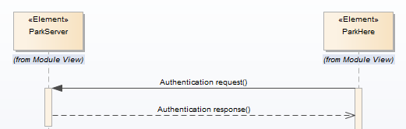
Figure 24. Authenticate actors

Encrypt data
The private data in network should be treated with care. System encrypt these messages with “XXTEA” encryption algorithm. At the beginning of project, we would apply whole messages between server and client. But the low performance of Arduino made us to select plan B for encryption. There are 2 main problems for encryption using Arduino.

1. It takes more than 5 seconds to encrypt ~200 bytes message.
2. Arduino also has a kind of limit to handle long message, experimentally under 200 bytes. But encryption makes message more than 1.5 times to 3 times. We already designed almost 200 bytes sized message, so it is hard to apply encryption thoroughly.

At this point, we decide to adopt encryption with small values, credit card information and password information.

Tactics for safety (QA-16)
This system includes hardware parking lot. We should not make any harm to people who use this system. To make this system safe, we use tactics.

Confirmation response
When we control hardware devices, entry/exit gate servo, LED lights at parking slots and entry/exit gate, the parking lot should send the executed result to server to declare it executed.

Subsystem Architecture Design
This section describes subsystem’s important architecture design.

ParkServer (SE-01)
ParkServer is the most important element in this system. It covers 97% of requirements, it controls whole system. In this context, the design goals for ParkServer are availability, reliability and modifiability.

Static perspective
Before making dynamic perspective, we separated modules with their responsibilities.

Elements | Responsibility | Assignee
Communication Manager | - connect with devices all around system  - send command to devices  - receive status of devices  - parse the information and route to adequate manager
Reservation Manager | - manage current parking lot status  - manage parking fee/grace period for reservation  - provide current available reservation information  - calculate parking fee  - request to check parking fee
Authentication Manager | - validate authority by id/pw  - possible authorities : owner, attendant, driver
ParkingLot Manager | - control parking lot devices  - manage parking lot status
Statistics Manager | - analyze statistics from usage/reservation data  - adapt new algorithms easily
Network Manager | - run server and create sockets for clients  - messages in network is encrypted and decrypted using security manager
Security Manager | -
Database Manager

Dynamic perspective
ParkServer is the most important element in this system. It covers 97% of requirements, it controls whole system.

